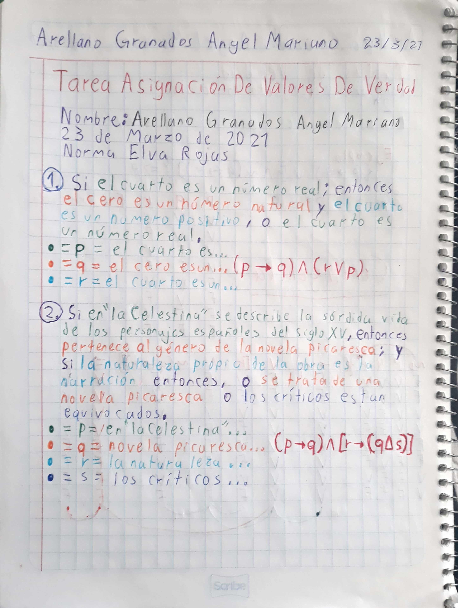

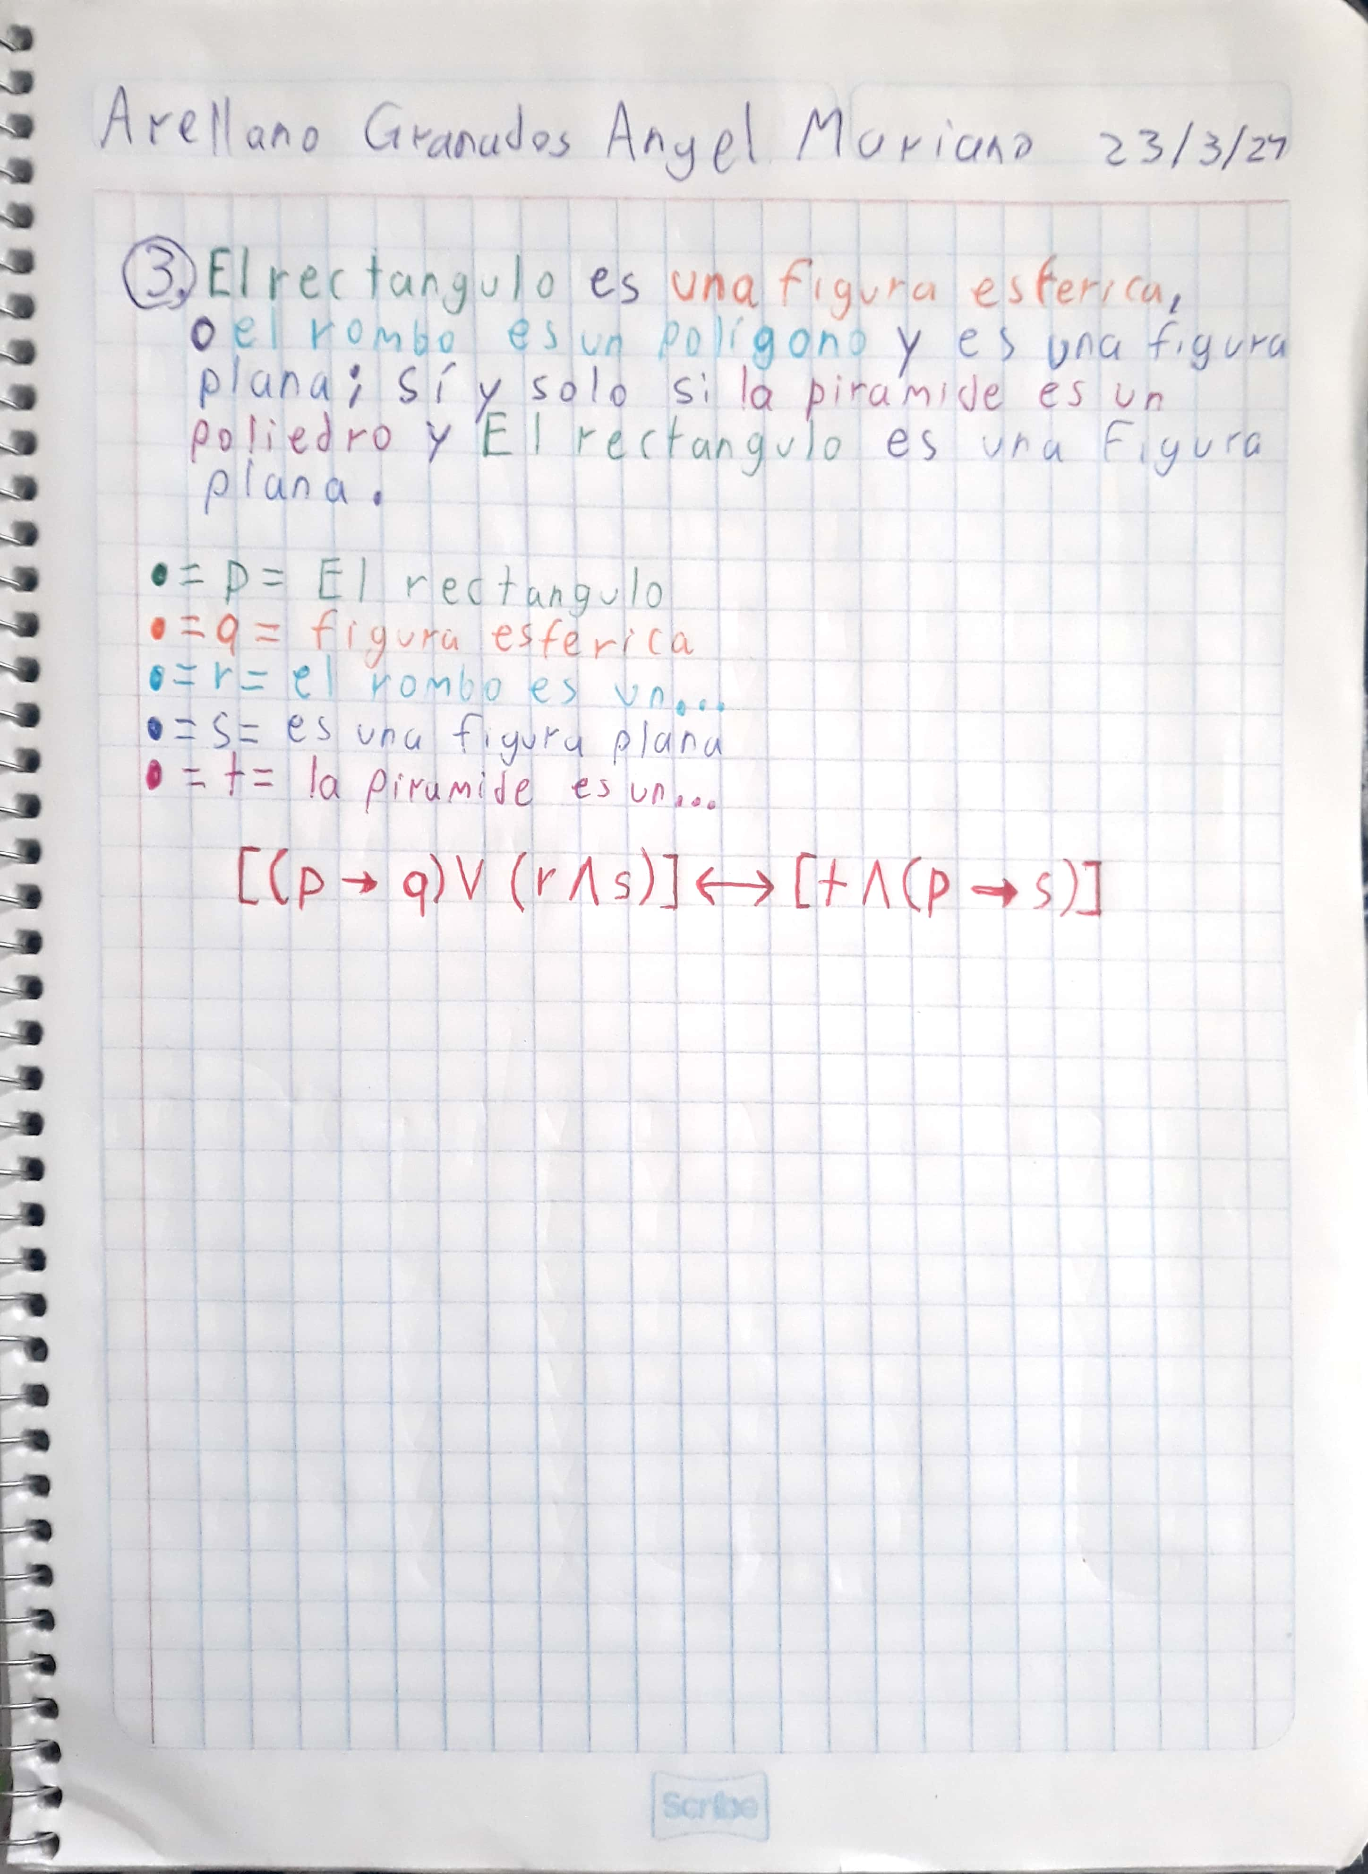

1. Construye las tablas de verdad de los siguientes enunciados
   1. ( p Ʌ q ) → ( q V ~p )

|  |  |  |  |  |  |
| --- | --- | --- | --- | --- | --- |
| **a.    ( p Ʌ q ) → ( q V ~p )** | | | | | |
| p | q | ~ p | ( p Ʌ q ) | ( q V ~p ) | ( p Ʌ q ) → ( q V ~p ) |
| V | V | F | V | V | V |
| V | F | F | F | F | V |
| F | V | V | F | V | V |
| F | F | V | F | V | V |

TAUTOLOGIA

* 1. p ↔ [ ( q V ~p ) Ʌ ~q]

|  |  |  |  |  |  |  |
| --- | --- | --- | --- | --- | --- | --- |
| **b. p ↔ [ ( q V ~p ) Ʌ ~q]** | | | | | |  |
| p | q | ~ p | ~ q | ( q V ~p ) | [ ( q V ~p ) Ʌ ~q] | p ↔ [ ( q V ~p ) Ʌ ~q] |
| V | V | F | F | V | F | F |
| V | F | F | V | F | F | F |
| F | V | V | F | V | F | V |
| F | F | V | V | V | V | F |

CONTINGENCIA

* 1. { [ ( p Ʌ q ) V ( r Ʌ s ) ] → ( t V ~q ) }

|  |  |  |  |  |  |  |  |  |  |  |
| --- | --- | --- | --- | --- | --- | --- | --- | --- | --- | --- |
| **c. { [ ( p Ʌ q ) V ( r Ʌ s ) ] → ( t V ~q ) }** | | | | | | | | | | |
| p | q | r | s | t | ~ q | ( p Ʌ q ) | ( r Ʌ s ) | [ ( p Ʌ q ) V ( r Ʌ s ) ] | ( t V ~q ) | { [ ( p Ʌ q ) V ( r Ʌ s ) ] → ( t V ~q ) } |
| V | V | V | V | V | F | V | V | V | V | V |
| V | V | V | V | F | F | V | V | V | F | F |
| V | V | V | F | V | F | V | F | V | V | V |
| V | V | V | F | F | F | V | F | V | F | F |
| V | V | F | V | V | F | V | F | V | V | V |
| V | V | F | V | F | F | V | F | V | F | F |
| V | V | F | F | V | F | V | F | V | V | V |
| V | V | F | F | F | F | V | F | V | F | F |
| V | F | V | V | V | V | F | V | V | V | V |
| V | F | V | V | F | V | F | V | V | V | V |
| V | F | V | F | V | V | F | F | F | V | V |
| V | F | V | F | F | V | F | F | F | V | V |
| V | F | F | V | V | V | F | F | F | V | V |
| V | F | F | V | F | V | F | F | F | V | V |
| V | F | F | F | V | V | F | F | F | V | V |
| V | F | F | F | F | V | F | F | F | V | V |
| F | V | V | V | V | F | F | V | V | V | V |
| F | V | V | V | F | F | F | V | V | F | F |
| F | V | V | F | V | F | F | F | F | V | V |
| F | V | V | F | F | F | F | F | F | F | V |
| F | V | F | V | V | F | F | F | F | V | V |
| F | V | F | V | F | F | F | F | F | F | V |
| F | V | F | F | V | F | F | F | F | V | V |
| F | V | F | F | F | F | F | F | F | F | V |
| F | F | V | V | V | V | F | V | V | V | V |
| F | F | V | V | F | V | F | V | V | V | V |
| F | F | V | F | V | V | F | F | F | V | V |
| F | F | V | F | F | V | F | F | F | V | V |
| F | F | F | V | V | V | F | F | F | V | V |
| F | F | F | V | F | V | F | F | F | V | V |
| F | F | F | F | V | V | F | F | F | V | V |
| F | F | F | F | F | V | F | F | F | V | V |

CONTINGENCIA